Experiment (1): Extracting Stay points (preprocessing)

Introduction:

The human mobility patterns are considered as spaitio-temporal data, which change in both time and space (location).

We are studying the human mobility patterns in daily bases, this work is aimed to be able to infer and predict these daily behaviors in order to advance the location applications and generate new apps which can be customized for every single user using his/her location data. This work can coup with other human patterns like behavior and usage.

Problem definition:

The target of this experiment is to discretize the GPS readings into stay points, which are the regions where the user spent more time than a threshold, and within area of certain geographical diameter.

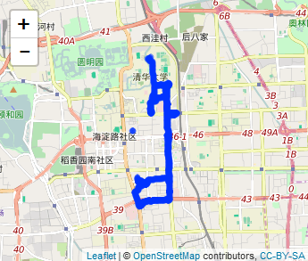

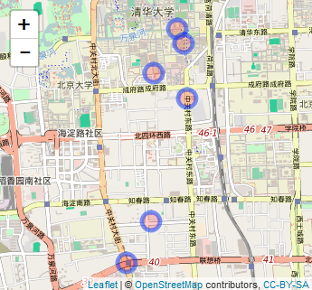

Inputs:

* We use GPS records (longitude, latitude, time, date) from Geolife dataset, which contains 182 users collected in 4 years.
* Time threshold (Tth)
* Space threshold (Sth)

Outputs:

* List of Stay points (SP) with each arrival time (ArrTime) and leave time (LevTime)

Algorithm:

Assume:

* + Counters I, j for traversing GPS points.

Results: